1. On the perch diagram below, the structure labeled “a” is
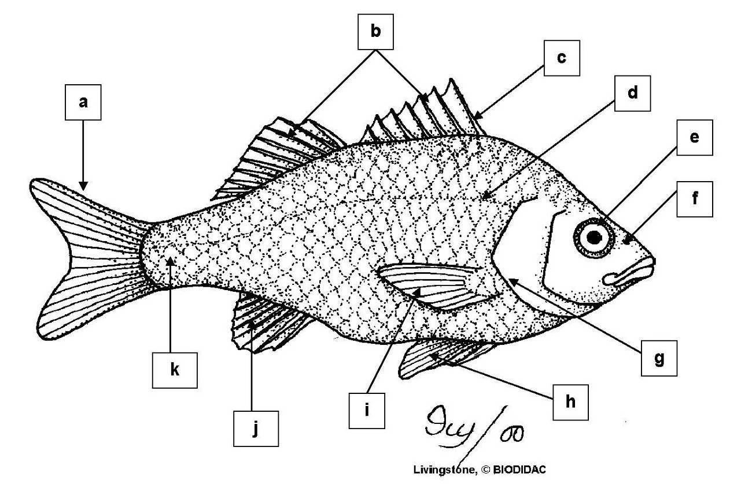

a. anal fin
*b. caudal fin
c. dorsal fin
d. fin ray
e. pectoral fin
f. pelvic fin

2. On the perch diagram below, the structure labeled “b” is

a. anal fin
b. caudal fin
*c. dorsal fin
d. fin ray
e. pectoral fin
f. pelvic fin

3. On the perch diagram below, the structure labeled “c” is

a. anal fin
b. caudal fin
c. dorsal fin
*d. fin ray
e. pectoral fin
f. pelvic fin

4. On the perch diagram below, the structure labeled “h” is

a. anal fin
b. caudal fin
c. dorsal fin
d. fin ray
e. pectoral fin
*f. pelvic fin

5. On the perch diagram below, the structure labeled “i” is

a. anal fin
b. caudal fin
c. dorsal fin
d. fin ray
*e. pectoral fin
f. pelvic fin

6. On the perch diagram below, the structure labeled “j” is

*a. anal fin
b. caudal fin
c. dorsal fin
d. fin ray
e. pectoral fin
f. pelvic fin

7. On the perch diagram below, the structure labeled “f” is

a. eye
b. lateral line
*c. nostril
d. operculum
e. scale

8. On the perch diagram below, the structure labeled “g” is

a. eye
b. lateral line
c. nostril
*d. operculum
e. scale

9. On the perch diagram below, the structure labeled “d” is

a. eye
*b. lateral line
c. nostril
d. operculum
e. scale

10. On the perch diagram below, the structure labeled "a" is
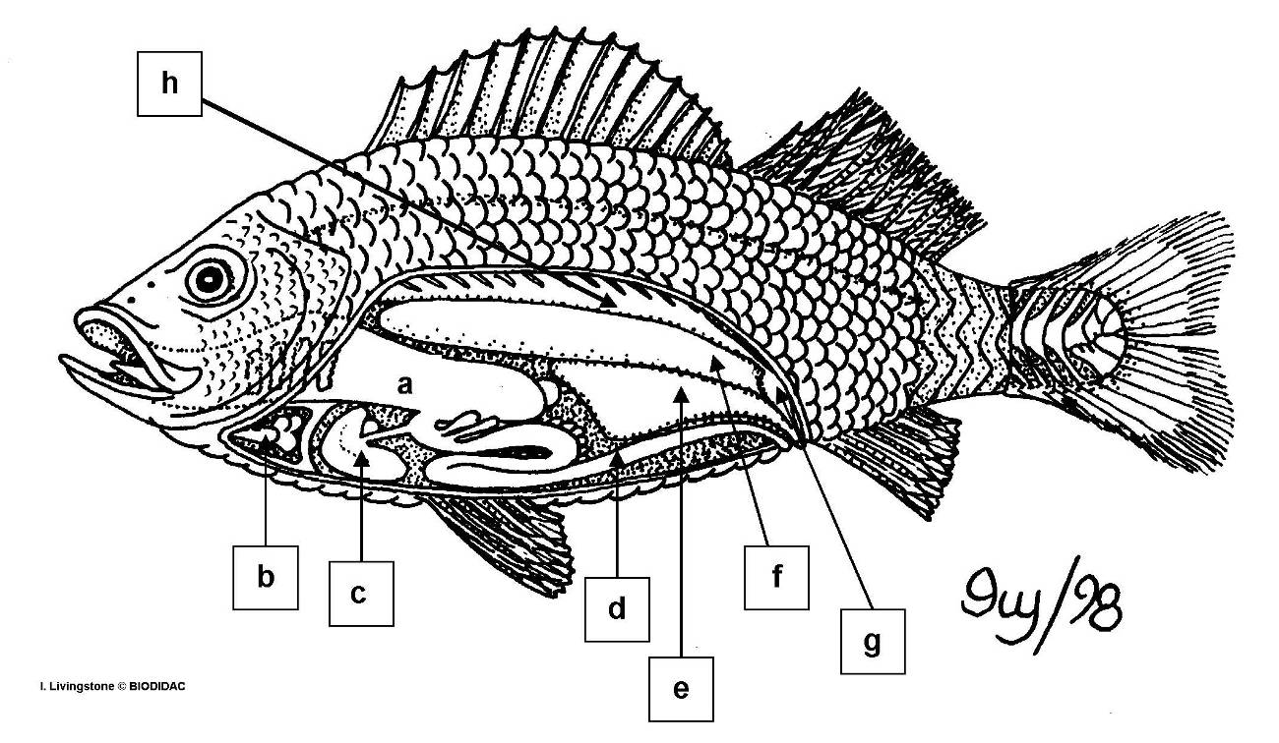

a. gonad (testes or ovaries)
b. heart
c. intestine
d. kidney
e. liver
*f. stomach
g. swim bladder
h. urinary bladder

11. On the perch diagram below, the structure labeled "b" is

a. gonad (testes or ovaries)
*b. heart
c. intestine
d. kidney
e. liver
f. stomach
g. swim bladder
h. urinary bladder

12. On the perch diagram below, the structure labeled "c" is

a. gonad (testes or ovaries)
b. heart
c. intestine
d. kidney
*e. liver
f. stomach
g. swim bladder
h. urinary bladder

13. On the perch diagram below, the structure labeled "d" is

a. gonad (testes or ovaries)
b. heart
*c. intestine
d. kidney
e. liver
f. stomach
g. swim bladder
h. urinary bladder

14. On the perch diagram below, the structure labeled "e" is

*a. gonad (testes or ovaries)
b. heart
c. intestine
d. kidney
e. liver
f. stomach
g. swim bladder
h. urinary bladder

15. On the perch diagram below, the structure labeled "f" is

a. gonad (testes or ovaries)
b. heart
c. intestine
d. kidney
e. liver
f. stomach
*g. swim bladder
h. urinary bladder

16. On the perch diagram below, the structure labeled "g" is

a. gonad (testes or ovaries)
b. heart
c. intestine
d. kidney
e. liver
f. stomach
g. swim bladder
*h. urinary bladder

17. On the perch diagram below, the structure labeled "h" is

a. gonad (testes or ovaries)
b. heart
c. intestine
*d. kidney
e. liver
f. stomach
g. swim bladder
h. urinary bladder

